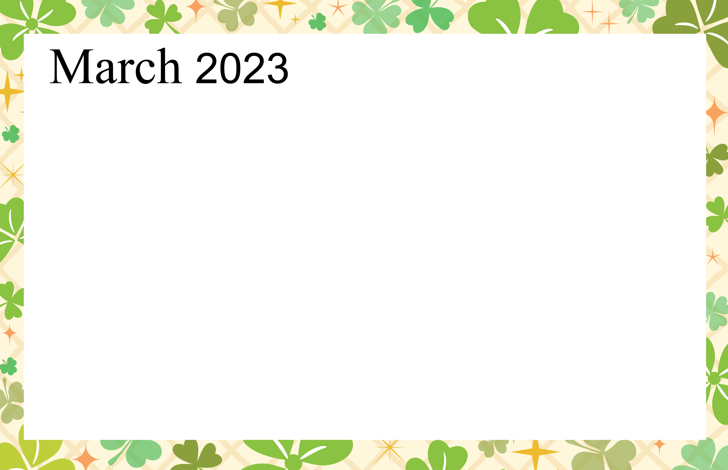  3rd Floor Activities |  |  | 10:30 Manicures  1:30 Trivia Time  2:30 Balloon Volleyball | 10:30 Sing-a-Long  1:30 Ice Cream Social  2:00 Catholic Communion& Prayer-Parlor  2:30 Finish Lines | 10:30 Game Time  1:30 Coloring & Puzzles  2:00 Happy Hour - Lobby | 10:30 Movie Time
9:00 Catholic Communion - Parlor  11:30 Ministry Service | 10:30 Devotional Gathering - Parlor  11:00 Balloon Volleyball  2:00 Cookie Baking  3:00 Coloring | 10:30 Arts & Crafts  11:00 Chair Exercise  2:30 Puzzles & Games | 10:30 Manicures  1:30 Trivia Time  2:00 Entertainer – Lynn Roxy | 10:30 Sing-a-Long  1:30 Ice Cream Social  2:00 Catholic Communion& Prayer-Parlor  2:30 Finish Lines | 10:30 Game Time  1:30 Coloring & Puzzles  2:00 Happy Hour - Lobby | 10:30 Movie Time
9:00 Catholic Communion - Parlor  11:30 Ministry Service | 10:30 Devotional Gathering - Parlor  11:00 Balloon Volleyball  2:00 Cookie Baking  3:00 Coloring | 10:30 Arts & Crafts  11:00 Chair Exercise  2:00 Entertainer – Lynn Roxy | 10:30 Manicures  1:30 Trivia Time  2:30 Balloon Volleyball | 10:30 Sing-a-Long  1:30 Ice Cream Social  2:00 Catholic Communion& Prayer-Parlor  2:30 Finish Lines | 10:30 Game Time  1:30 Coloring & Puzzles  2:00 Happy Hour - Lobby | 10:30 Movie Time
9:00 Catholic Communion - Parlor  11:30 Ministry Service | 10:30 Devotional Gathering - Parlor  11:00 Balloon Volleyball  2:00 Cookie Baking  3:00 Coloring | 10:30 Arts & Crafts  11:00 Chair Exercise  2:30 Puzzles & Games | 10:30 Manicures  1:30 Trivia Time  2:30 Balloon Volleyball | 10:30 Sing-a-Long  1:30 Ice Cream Social  2:00 Catholic Communion& Prayer-Parlor  2:30 Finish Lines | 10:30 Game Time  1:30 Coloring & Puzzles  2:00 Happy Hour - Lobby | 10:30 Movie Time
9:00 Catholic Communion - Parlor  11:30 Ministry Service | 10:30 Devotional Gathering - Parlor  11:00 Balloon Volleyball  2:00 Cookie Baking  3:00 Coloring | 10:30 Arts & Crafts  11:00 Chair Exercise  2:30 Puzzles & Games | 10:30 Manicures  1:30 Trivia Time  2:30 Balloon Volleyball | 10:30 Sing-a-Long  1:30 Ice Cream Social  2:00 Catholic Communion& Prayer-Parlor  2:00 Entertainer – Lynn Roxy | 10:30 Game Time  1:30 Coloring & Puzzles  2:00 Happy Hour - Lobby | 10:30 Movie Time
Harmony Hall
Sunday | Monday | Tuesday | Wednesday | Thursday | Friday | Saturday
 |  |  | 1 | 2 | 3 | 4
5 | 6  Purim Begins | 7 | 8 | 9 | 10 | 11
12  Daylight Saving Time Begins | 13 | 14 | 15 | 16 | 17  St. Patrick’s Day | 18
19 | 20  Spring Begins | 21 | 22  Ramadan Begins | 23 | 24 | 25
26 | 27 | 28 | 29 | 30 | 31

