1st & 2nd Floor Activities |  |  | 9:30 Current Events – 2F  10:00 Trivia – 2F  1:00 Music Appreciation – MT  1:30 BINGO – 2F | 9:30 Current Events – 2F  10:30 Armchair Travel : Alaska’s Call of the Wild - MT  1:00 Manicures – 2F  2:00 Catholic Communion & Prayer - Parlor  6:00 Movie Night - MT | 9:30 Current Events – 2F  10:30 Deal or No Deal– 2F  2:00 Happy Hour with Vintage Entertainment- Lobby  6:00 Movie Night - MT | 10:00 Songs for Seniors - Lobby  1:30 BINGO – 2F
9:00 Catholic Communion - Parlor  1:00 Movie Matinee – MT  1:30 BINGO – 2F  6:00 Movie Night - MT | 9:30 Current Events – 2F  10:30 Devotional Gathering - Parlor  10:30 Residents Choice - 2F  1:30 BINGO – 2F  6:00 Movie Night - MT | 10:00 Movement Exploration – Lobby  1:30 Ice Cream Social – 2F  2:30 Card Games – 2F  6:00 Movie Night – MT | 9:30 Current Events – 2F  10:00 Trivia – 2F  1:00 Music Appreciation – MT  1:30 BINGO – 2F | 9:30 Current Events – 2F  10:00 Name That Tune – 2F  11:00 Jewish Services - Parlor  1:00 Manicures – 2F  2:00 Catholic Communion & Prayer – Parlor  2:30 Arts & Crafts – 2F  6:00 Movie Night - MT | 9:30 Current Events – 2F  10:30 Deal or No Deal– 2F  2:00 Happy Hour with Julie Hall - Lobby  6:00 Movie Night – MT | 1:30 BINGO – 2F
9:00 Catholic Communion - Parlor  1:00 Movie Matinee – MT  1:30 BINGO – 2F  6:00 Movie Night - MT | 9:30 Current Events – 2F  10:30 Devotional Gathering - Parlor  10:30 Residents Choice - 2F  1:30 BINGO – 2F  6:00 Movie Night - MT | 10:00 Movement Exploration – Lobby  1:30 Ice Cream Social – 2F  2:30 Card Games – 2F  6:00 Movie Night – MT | 9:30 Current Events – 2F  10:00 Dr. Lazris – 2F  1:00 Music Appreciation – MT  1:30 BINGO – 2F | 9:30 Current Events – 2F  10:00 Name That Tune – 2F  10:00 Armchair Travel – Alaska’s Fire and Ice - MT  1:00 Manicures – 2F  2:00 Catholic Communion & Prayer – Parlor  2:30 A Day at the Races – 2F  6:00 Movie Night - MT | 9:30 Current Events – 2F  10:30 Deal or No Deal– 2F  2:00 St. Patrick’s Day Happy Hour with Paul Jude- Lobby  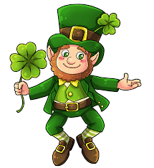  6:00 Movie Night – MT | 1:30 BINGO – 2F
9:00 Catholic Communion - Parlor  1:00 Movie Matinee – MT  1:30 BINGO – 2F  6:00 Movie Night - MT | 9:30 Current Events – 2F  10:30 Devotional Gathering - Parlor  10:30 Residents Choice - 2F  1:30 BINGO – 2F  6:00 Movie Night - MT | 10:00 Movement Exploration – Lobby  1:30 Ice Cream Social – 2F  2:30 Card Games – 2F  6:00 Movie Night – MT | 9:30 Current Events – 2F  10:00 Alaska Trivia– 2F  1:00 Music Appreciation – MT  1:30 BINGO – 2F | 9:30 Current Events – 2F  10:00 Name That Tune – 2F  11:00 Jewish Services - Parlor  1:00 Manicures – 2F  1:30 Men’s Club Presentation of The Battle of the Bulge - MT  2:00 Catholic Communion & Prayer – Parlor  6:00 Movie Night - MT | 9:30 Current Events – 2F  10:00 Q & A – 2F  2:00 Happy Hour with Steve Flynn- Lobby  6:00 Movie Night - MT |   1:30 BINGO – 2F
9:00 Catholic Communion - Parlor  1:00 Movie Matinee – MT  1:30 BINGO – 2F  6:00 Movie Night - MT | 9:30 Current Events – 2F  10:30 Devotional Gathering - Parlor  10:30 Residents Choice - 2F  1:30 BINGO – 2F  6:00 Movie Night - MT | 10:00 Movement Exploration – Lobby  11:00 Just Bead It – 2F  1:30 Ice Cream Social – 2F  2:30 Card Games – 2F  6:00 Movie Night – MT | 9:30 Current Events – 2F  10:00 Trivia – 2F  1:00 Music Appreciation – MT  1:30 BINGO – 2F | 9:30 Current Events – 2F  10:00 Name That Tune – 2F  10:30 Resident Trip to Olive Garden - Lobby  1:00 Manicures – 2F  2:00 Catholic Communion & Prayer – Parlor  6:00 Movie Night - MT | 9:30 Current Events – 2F  10:30 Deal or No Deal– 2F  2:00 Happy Hour with Julia Hall- Lobby  6:00 Movie Night - MT
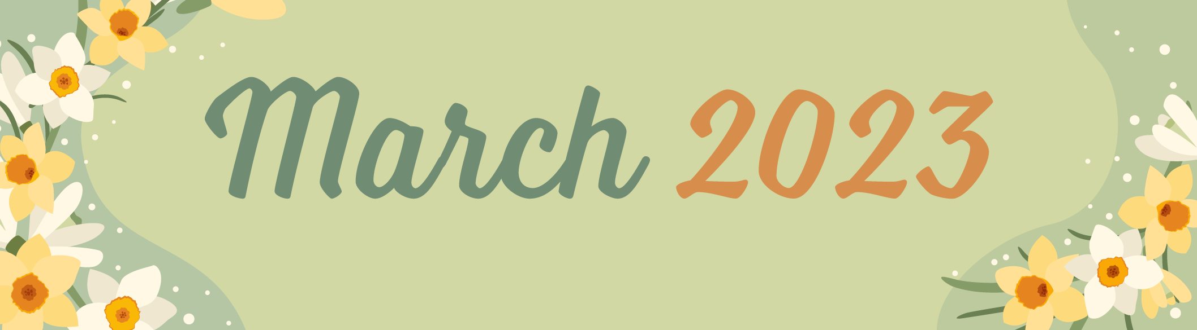
Harmony Hall
Sunday | Monday | Tuesday | Wednesday | Thursday | Friday | Saturday
 |  |  | 1 | 2 | 3 | 4
5 | 6  Purim Begins | 7 | 8 | 9 | 10 | 11
12  Daylight Saving Time Begins | 13 | 14 | 15 | 16 | 17  St. Patrick’s Day | 18
19 | 20  Spring Begins | 21 | 22  Ramadan Begins | 23 | 24 | 25
26 | 27 | 28 | 29 | 30 | 31

